NASA EVA Path Finder Phase 2

User Manual

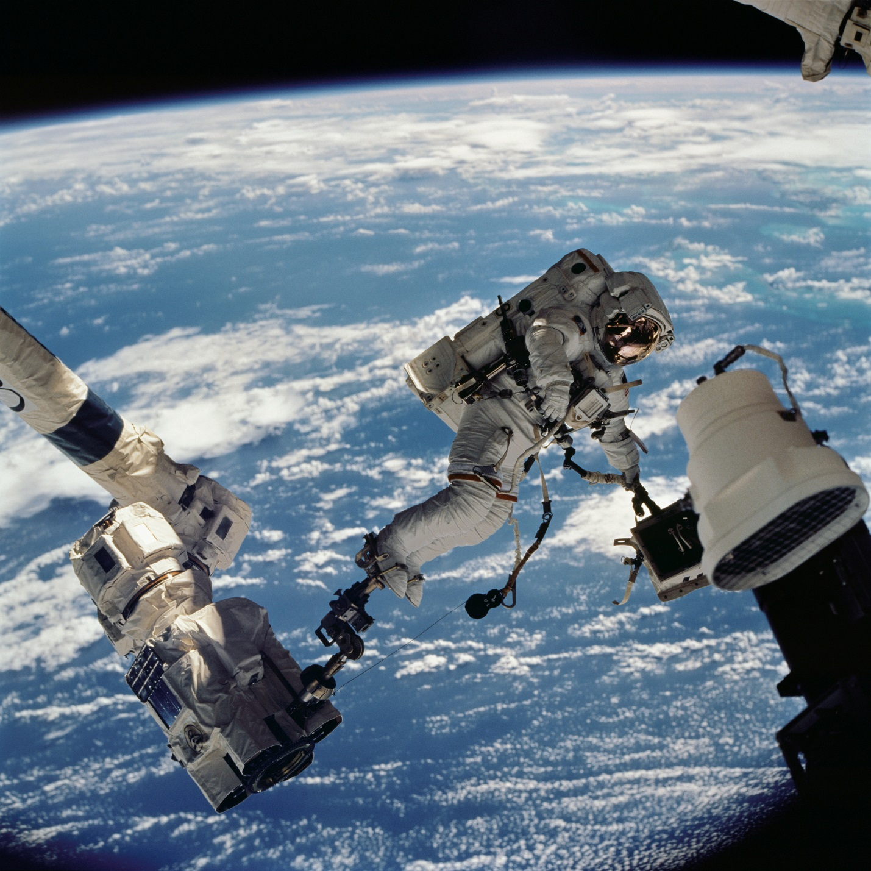



User Manual

**Prepared by**

**Nicoleta Florea, Bradley Hankinson, Brittany Ofori, George Wheeler, Justin Widmann**

User Manual

For

NASA EVA Path Finder: Phase 2

**Version 1.00 Approved**

Prepared by

Nicoleta Florea, Bradley Hankinson, Brittany Ofori, George Wheeler, Justin Widmann

University of Maryland University College

SWEN 670 9040

Software Engineering Project

April 22, 2018

**Contents**

1. Overview 6

1.1 Purpose 6

1.2 Intended Audience 6

1.3 Scope 6

1.4 References 6

2. Technical Stack 7

2.1 Front End 7

2.2 Back End 7

2.3 Supplemental Tools and Add-ins 7

3. Software Installation 8

3.1 Windows Installation 8

3.1.1 Step 1: Install Node.js 8

3.1.2 Step 2: Install Yarn 8

3.1.3 Step 3: Install or Update Java 8 9

3.1.4 Step 4: Install Maven (Apache Maven Project) 10

3.1.5 Step 5: Install Visual Studio 11

3.1.6 Step 6: Install Python 11

3.1.7 Step 7: Confirm File Locations 12

3.1.8 Step 8: Clone GitHub Repository 12

3.1.9 Step 9: Set Windows Environment Variables 12

3.1.10 Step 10: Yarn Dependencies 13

3.1.11 Step 11: Start Yarn (Front-End) 14

3.1.12 Step 12: Start Yarn (Server) 15

3.1.13 Step 13: Browser – Navigate to UI 16

3.2 Ubuntu Installation 17

3.2.1 Step 1: Install Node.js 17

3.2.2 Step 2: Install Yarn 17

3.2.3 Step 3: Install Java 17

3.2.4 Step 4: Install Maven 17

3.2.5 Step 5: GitHub 17

3.2.6 Step 6: Yarn Dependencies 18

3.2.7 Step 7: Yarn Start 18

3.2.8 Step 8: Yarn Compile 18

3.2.9 Step 9: Navigate to UI 18

4. Dynamic Onboard Ubiquitous Graphics (DOUG) Software 19

4.1 Overview 19

4.2 Registration 19

4.2.1 Step 1: Professor / Signatory Account 19

4.2.2 Step 2: Submit Request for Software 19

4.2.3 Step 3: Approval Confirmation 21

4.2.4 Step 4: Download DOUG Installation 22

4.2.5 Step 5: Activation Code 23

4.3 Installation 23

4.3.1 Step 1: Run DOUG Setup Installation 24

4.3.2 Step 2: Paste Activation Code 24

4.3.3 Step 3: Complete Wizard 24

4.3.4 Step 4: Confirm Installation 25

5. Common Errors and Fixes 26

5.1 Compile Exit Code 1 26

6. Frequently Asked Questions 26

6.1 What do I do if my package does not have a JSON file or NPM? 26

6.1.1 Create a Package – package.json 26

6.1.2 Install NPM Package 29

7. Appendix A: Glossary 29

Revision History

|  |  |  |  |
| --- | --- | --- | --- |
| **Name** | **Date** | **Reason For Changes** | **Version** |
| George Wheeler | 03/27/2018 | Combined installation documents into User Manual - Bradley Hankinson (Windows), - Nicoleta Florea (Ubuntu), and added the JSON and NPM instructions – Bradley Hankinson | 1.1 |
| George Wheeler | 03/31/2018 | Changed Outline of Document | 1.1 |
| Brad Hankinson | 04/01/2018 | Added screenshot of common error exit code 1, updated steps in Windows installation to omit server commands, and made minor formatting changes. | 1.2 |
| Brad Hankinson | 04/09/2018 | Added DOUG Software Registration and Installation sections | 1.3 |
| George Wheeler | 04/17/2018 | Made text formatting uniform throughout document. | 1.4 |
| Brad Hankinson | 04/20/2018 | Updated format, redacted contact information from DOUG screenshots, consolidated technical stack sections, and removed deprecated installation steps. | 1.5 |

# Overview

## Purpose

The purpose of this document is to serve as a singular reference to all things NASA EVA Path Finder for both first-time users and developers alike. Filling the roles of both a quick reference and general guide for managing the software, this document should evolve in parallel with the project throughout each phase.

## Intended Audience

This document was created for users and developers. It contains general information ranging from installation and configuration to troubleshooting.

Note: Enable Navigation Pane for outline navigation of the document by section.

## Scope

The scope of this document will expand with the requirements of the Path Finder project. It is intended to sufficiently describe installation, configuration, execution, and maintenance of the software for new users. Where appropriate, descriptions of functionality or specific feature details may be included.

As the software grows over time, new features that need supplemental instruction should be refactored into this resource. As this project reaches completion, this document will become the singular reference for installation and use of the software.

## References

Google Drive. (2017). NASA_Path_SRS_milestone3. Retrieved from <https://drive.google.com/drive/folders/1eLc_dxzsFKtd2MFow875MQICLlQenDCQ>

Google Drive. (2017). NASA_Path_Phase_2_Installation_Steps_Milestone2. Retrieved from <https://drive.google.com/drive/folders/1YBU0MWOCIDdFLKCbpWmRvhSZG1m_8L7x>

# Technical Stack

## Front End

Jest – Test Execution

NodeJS – Package Management

React – UI Rendering Library

ThreeJS – 3D Rendering

Webpack – Module Bundler

Yarn – Package Management

## Back End

AJAX – Asynchronous Algorithm Display

Java – Software Platform

## Supplemental Tools and Add-ins

CircleCI – Continuous Integration

Docker – Web Building

Electron – Build Management

GitHub – Code Repository

Python – Code Base

Visual Studio - .NET Framework

# Software Installation

## Windows Installation

The following steps describe the process of installing the NASA Path Finder software for the Windows OS. Command descriptions and example screenshots were taken in Windows 10.

### Step 1: Install Node.js

Download location:

<https://nodejs.org/en/>

Install to preferred location.

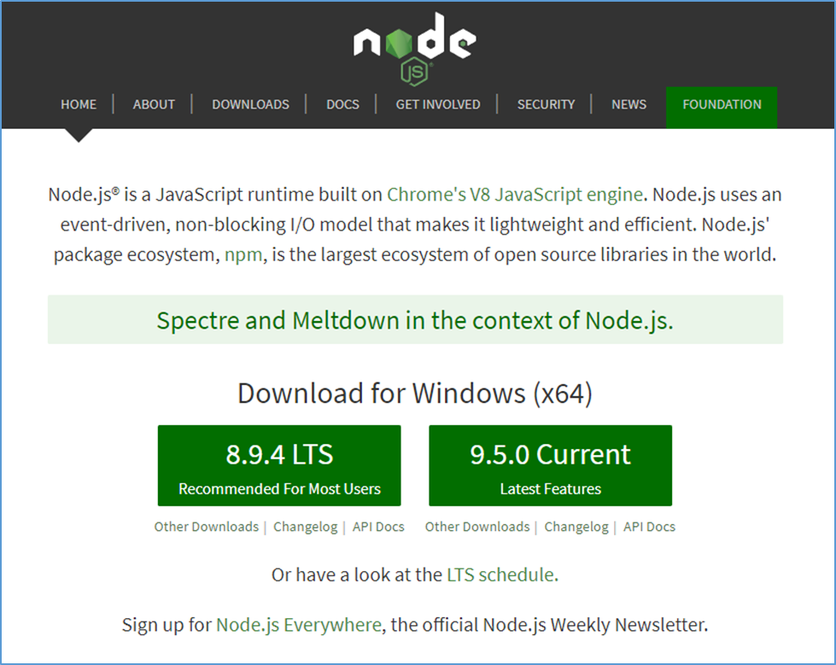

### Step 2: Install Yarn

Yarn is used to manage dependencies and execute the NASA Path software locally.

Download location:

<https://yarnpkg.com/en/docs/install>

Select the Windows.msi installation download. As shown below, Node.js should be installed before completing this step.

Use “Download Installer” and install at your preferred path.

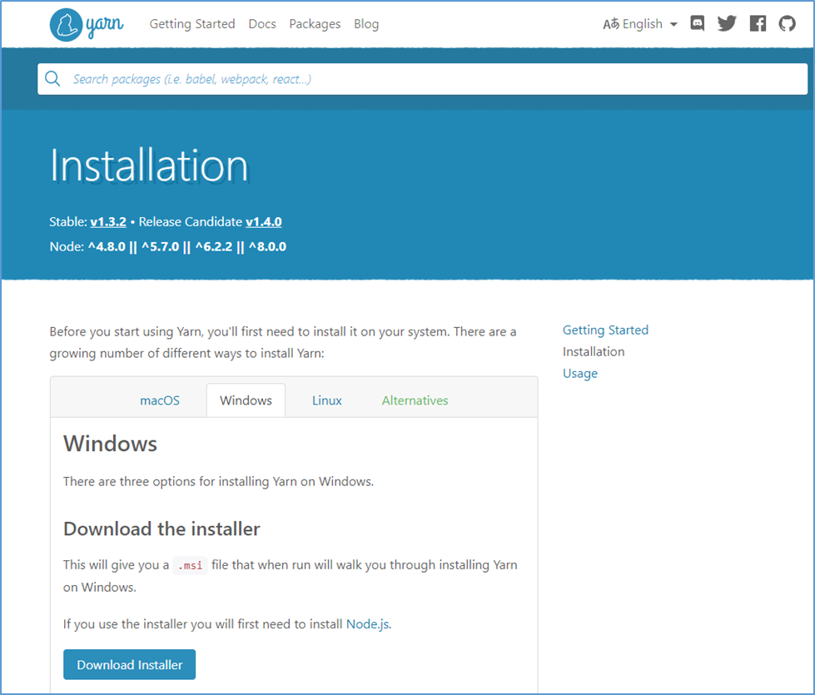

### Step 3: Install or Update Java 8

Download location:

<https://www.java.com/en/download/>

(Version 8 Update 161 at the time of this document).

Install to preferred location.

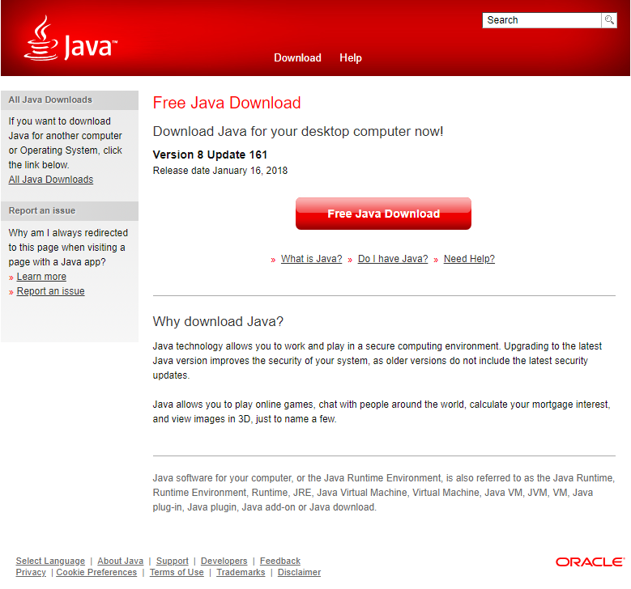

### Step 4: Install Maven (Apache Maven Project)

Download Location:

<https://maven.apache.org/>

(Version 3.5.2 at the time of this document).

Maven does not “install,” it’s a zipped folder that can be placed at your preferred location. Examples below place the folder in C:\.

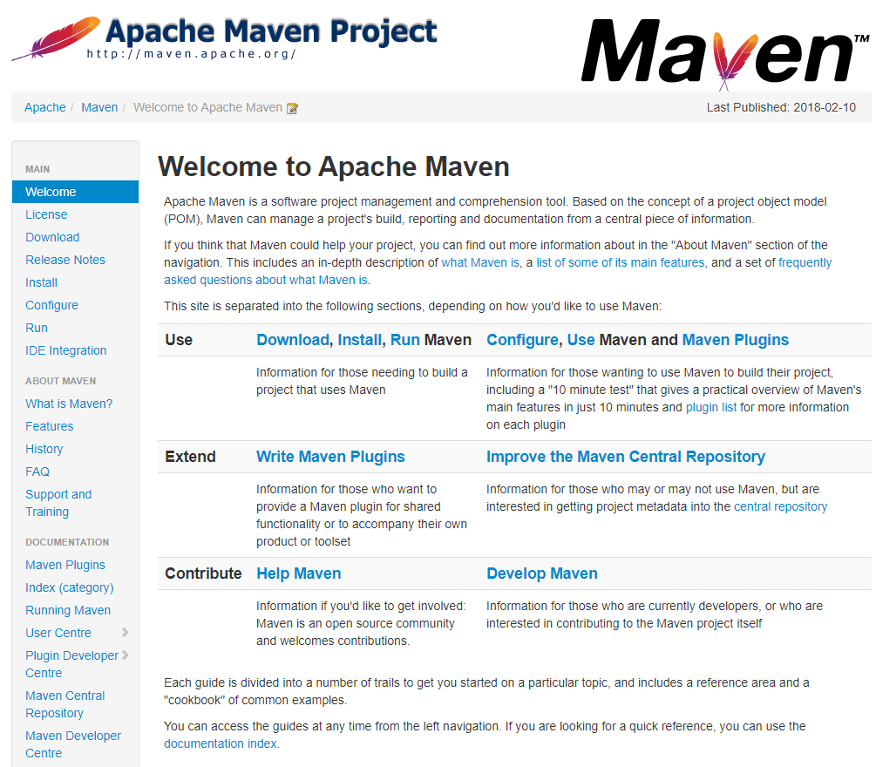

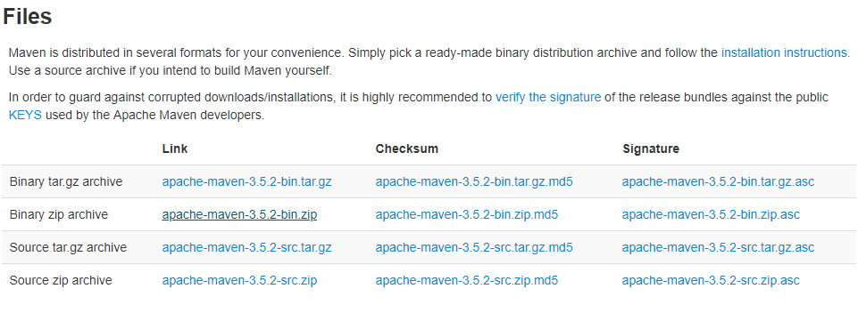

### Step 5: Install Visual Studio

Install Visual Studio for .NET Framework support. A free, community version is available.

Download Location:

<https://www.visualstudio.com/downloads/>

### Step 6: Install Python

Install Python.

Download Location:

<https://www.python.org/downloads/>

### Step 7: Confirm File Locations

Assuming you are using C:\ as your default location, copy the following folders here.

Place unzipped “apache-maven-3.5.2” installation folder in C:\

### Step 8: Clone GitHub Repository

Clone latest GitHub repository for a local copy.

• Navigate to https://github.com/xpaddict/nasa-path-finder

• Click “Clone or Download” button for repository URL

• Open command line window and navigate to target parent directory

* Command: git clone <PasteURL>

### Step 9: Set Windows Environment Variables

Access Windows environment variables via Control Panel. The search can be used with “environment variables” to provide a link to this configuration.

Note: Be sure to select environment variables for the system and not individual users.

Again, the following paths assume a default location of C:\, if you chose another location be sure to set the paths relative to that location.

If the following 3 paths do not exist, create them by clicking “New”:

1. JAVA_HOME – Locate the JDK folder where you installed Java 8

2. M2_HOME – Locate the apache maven folder

3. MAVEN_HOME – Locate the same apache maven folder

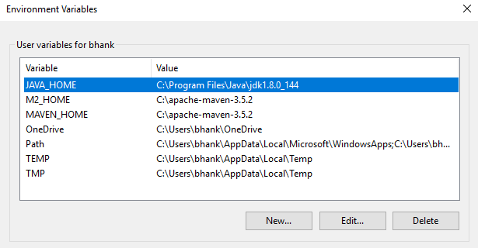

4. Select the “Path” Variable, Edit, and add “%M2_HOME%\bin”

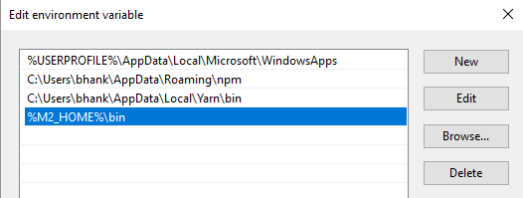

### Step 10: Yarn Dependencies

Update all yarn dependencies.

• Open a command window.

• Navigate to the /nasa-path-finder project directory and run “yarn” to download project dependencies. It may take a few minutes to complete the dependency downloads.

If you placed the folder in the C:\ directory, that would look like this:

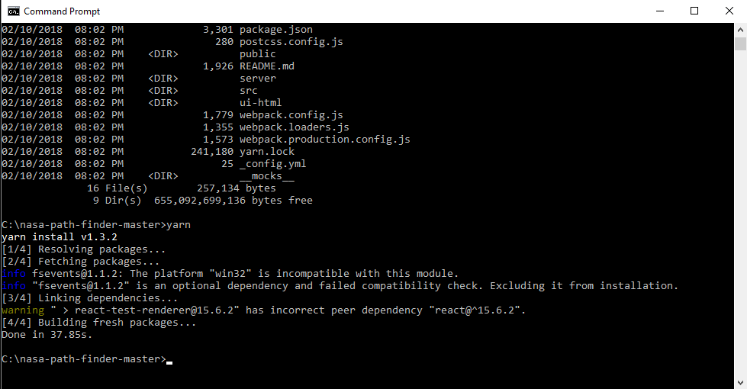

### Step 11: Start Yarn (Front-End)

Execute software front end.

• Open a command window.

• Navigate to the /nasa-path-finder project directory and run “yarn start” to execute the project at localhost:3000.

At this point two windows should open that look like this:

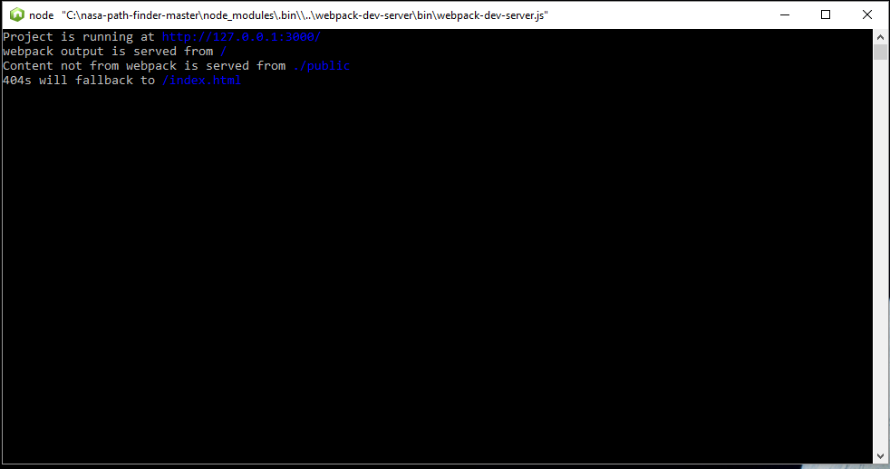

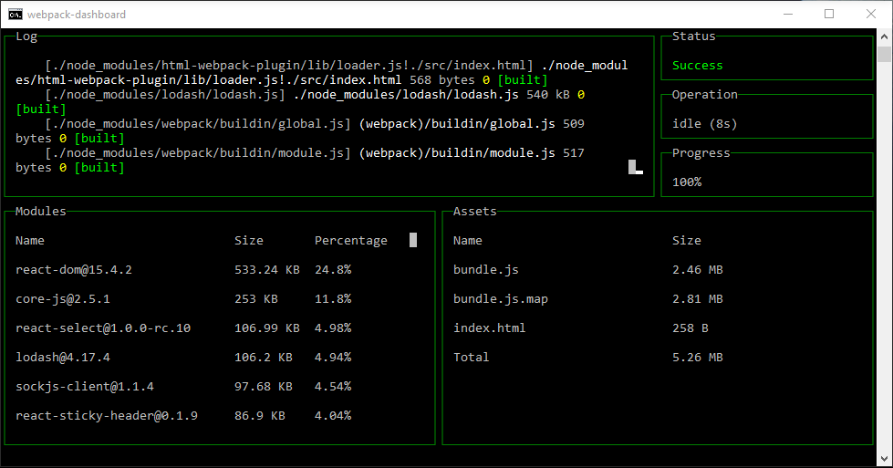

### Step 12: Start Yarn (Server)

Execute software back end.

• Leave the first two windows open and open a new command line window and navigate to the same project folder.

• Open another command window.

• Navigate to the /nasa-path-finder project directory and run “yarn compilewin:start:server”

It may take a few minutes and will download many files. Each execution after, it will look like this:

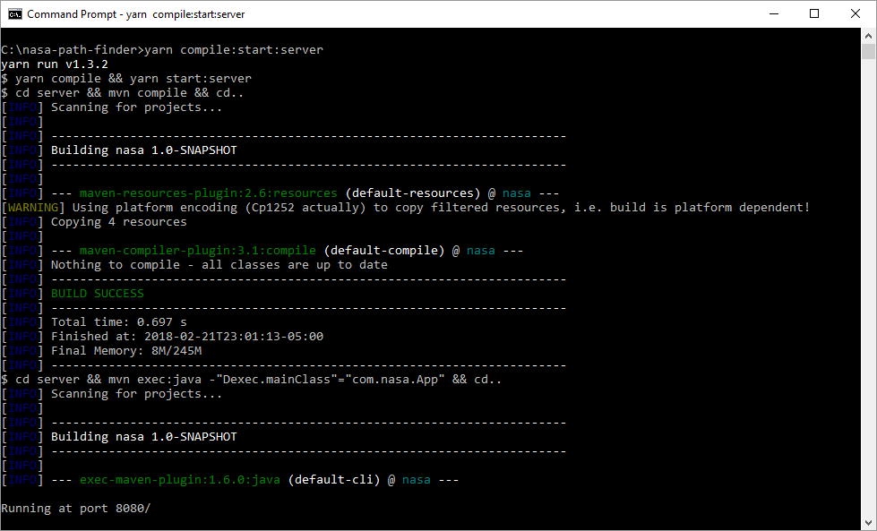

The last line should be “Running at port 8080/”

### Step 13: Browser – Navigate to UI

Open a browser and navigate to <http://127.0.0.1:3000> or <http://localhost:3000>

The tool should execute and load in the browser window:

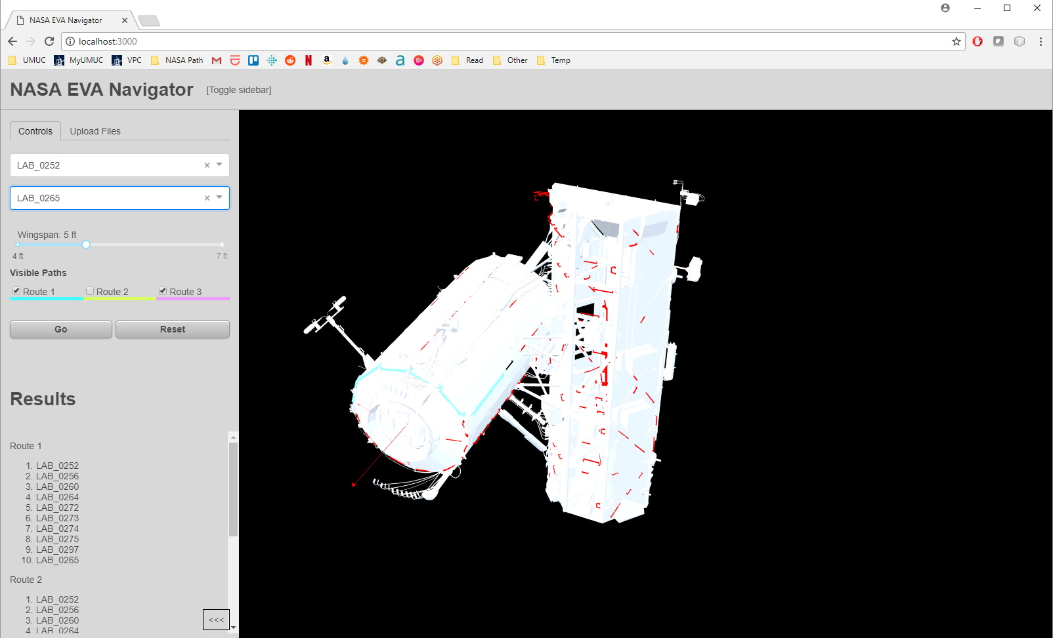

## Ubuntu Installation

The following steps describe the process of installing the NASA Path Finder software for the Ubuntu OS.

### Step 1: Install Node.js

$ sudo apt-get install nodejs

### Step 2: Install Yarn

$ curl -sS https://dl.yarnpkg.com/debian/pubkey.gpg | sudo apt-key add -

$ echo "deb https://dl.yarnpkg.com/debian/ stable main" | sudo tee

/etc/apt/sources.list.d/yarn.list

$ sudo apt-get update && sudo apt-get install yarn

### Step 3: Install Java

$ sudo apt-get install oracle-java8-installer

Check java version:

$ java -version

### Step 4: Install Maven

$ apt-cache search maven

Check maven version:

$ mvn -version

Or to check that installed version is latest and greatest:

$ sudo apt-get --only-upgrade install maven

### Step 5: GitHub

Configure GitHub

* Create GitHub Account
* Install GitHub

$ sudo apt-get update

$ sudo apt-get install git

* Navigate to Repository

<https://github.com/xpaddict/nasa-path-finder>

Click green "Clone / Download" button and copy the URL it provides

$ git clone <URL you just copied>

### Step 6: Yarn Dependencies

New terminal (*Ctrl+Alt+T*)

$ cd nasa-path-finder

$ yarn

If node error happens, use:

$ yarn –ignore-engines

### Step 7: Yarn Start

New terminal (*Ctrl+Alt+T*)

$ cd nasa-path-finder

$ yarn start

### Step 8: Yarn Compile

New terminal (*Ctrl+Alt+T*)

$ cd nasa-path-finder

$ yarn compile:start:server

### Step 9: Navigate to UI

Open a browser and navigate to <http://127.0.0.1:3000> or <http://localhost:3000>

The tool should execute and load in the browser:



# Dynamic Onboard Ubiquitous Graphics (DOUG) Software

## Overview

This section describes the processes for application and installation of the DOUG modeling software. Access is provided on a machine-by-machine basis. So, all team members should apply for permission as early as possible in the semester phase.

## Registration

### Step 1: Professor / Signatory Account

Professor should sign in and confirm the signatory account is still active and can accept a new request. His account will serve as signatory authority for the registration request.

Current signatory authority is registered to:

Michael Brown

[michael.brown@umuc.edu](mailto:michael.brown@umuc.edu)

### Step 2: Submit Request for Software

* Navigate to http://software.nasa.gov and search applications for “DOUG”

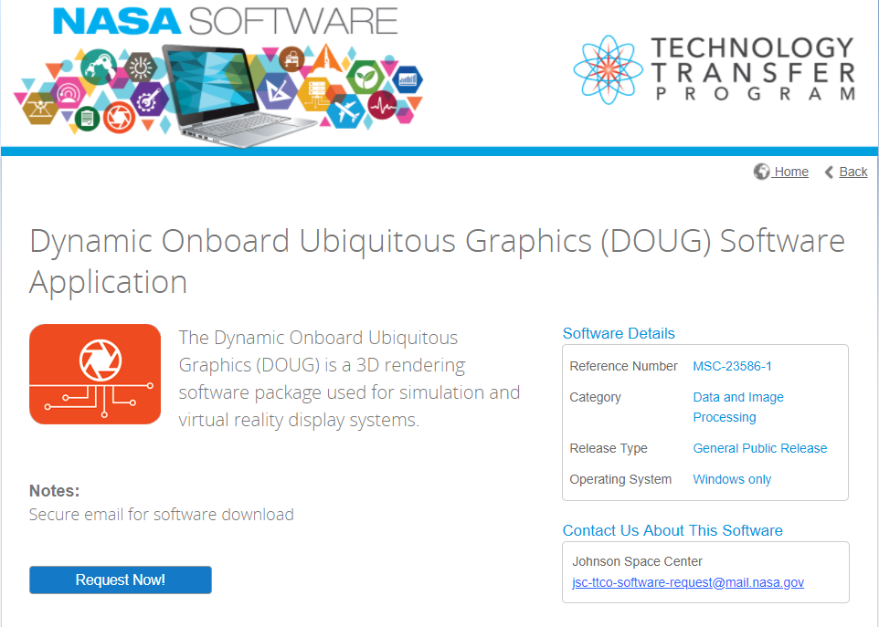

* Select “Request Now!”
* Create a New Account
* Complete Software Usage Agreement Questionnaire

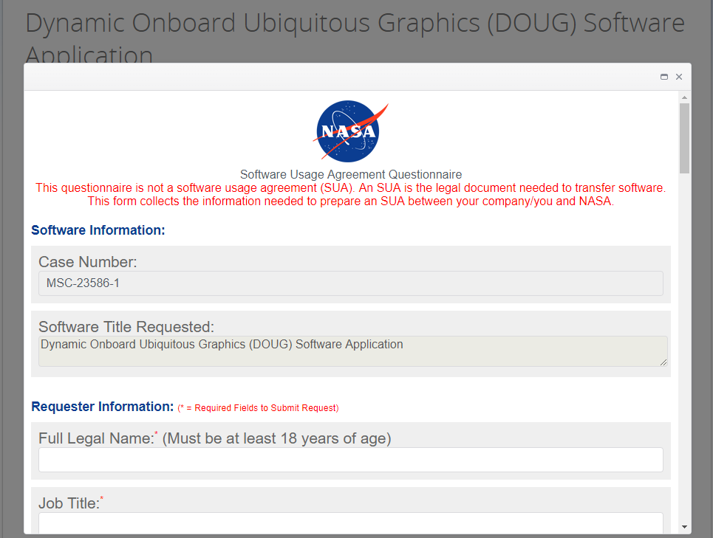

* Enter professor’s information (Full Name and Business Email) as Signature Authority

Contact.

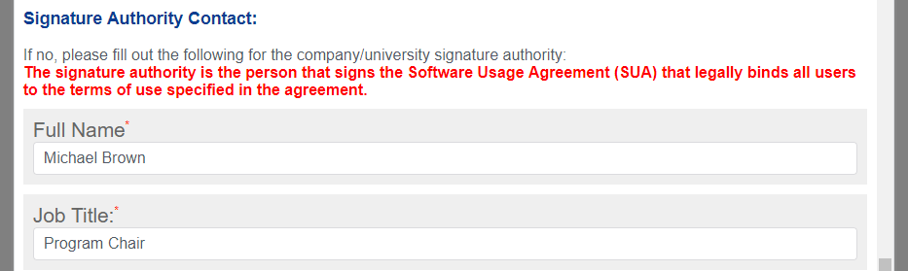

* The following automated email confirmation will be sent to the registering email.

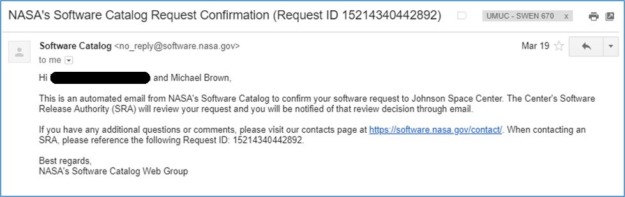

### Step 3: Approval Confirmation

Once submitted, it will take time to receive access. For our phase, it took 14 days before receiving the confirmation emails below.

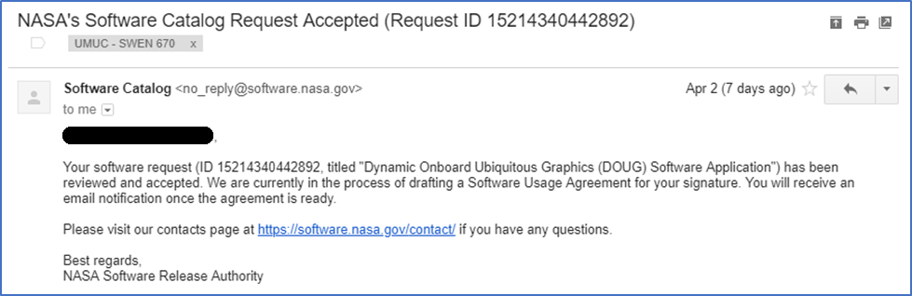

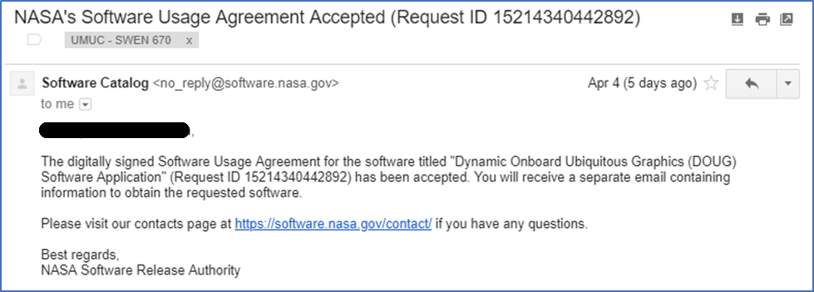

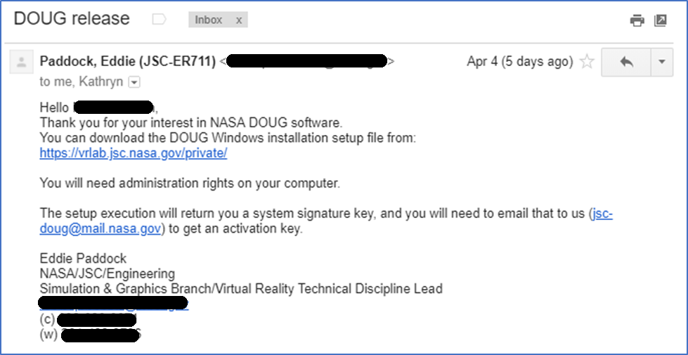

### Step 4: Download DOUG Installation

• From the link in the DOUG Release, navigate to the DOUG Installation Setup File at

<https://vrlab.jsc.nasa.gov/private/>

• Select respective OS

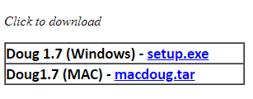

• Run respective installation setup file

• Copy the value of “Your System Signature: XXXXXXXXXX”

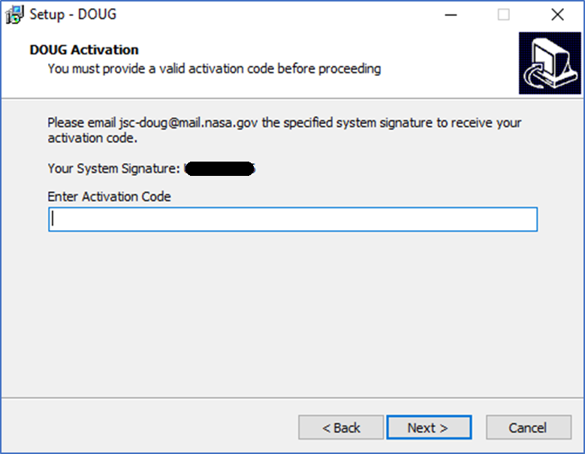

• Email System Signature to jsc-doug@mail.nasa.gov to receive activation code

### Step 5: Activation Code

After forwarding the System Signature, it will not take long to receive the activation code (less than 30 minutes for my request).

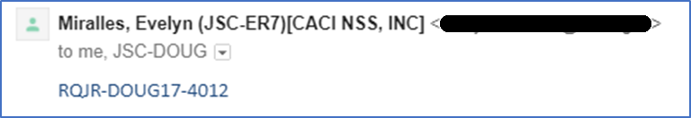

This Activation Code (Format: XXXX-XXXXXX-XXXX) will be used in the Installation process.

## Installation

### Step 1: Run DOUG Setup Installation

After receiving the Activation Code, the DOUG software can be installed. Run the Installation Setup file downloaded in Registration Step 4.

### Step 2: Paste Activation Code

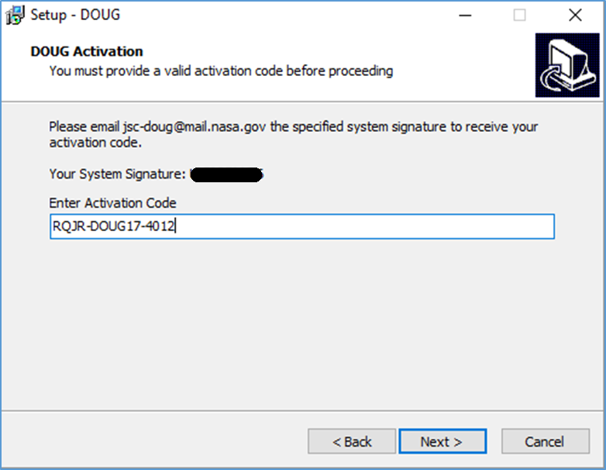

### Step 3: Complete Wizard

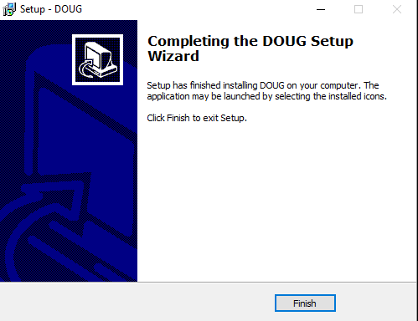

### Step 4: Confirm Installation

Installation complete! You should be able to click on the DOUG icon created during installation and wait for the application to render:

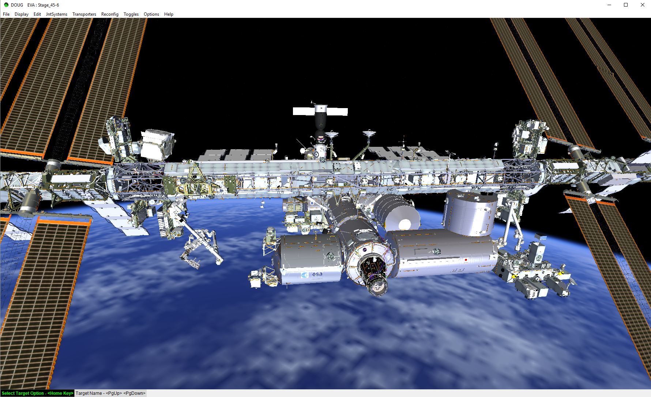

# Common Errors and Fixes

## Compile Exit Code 1

If you are receiving the exit code 1 error, you are compiling for the wrong operating system. The Windows compilation can be run with “compilewin” or run with “compilewin:start:server”.

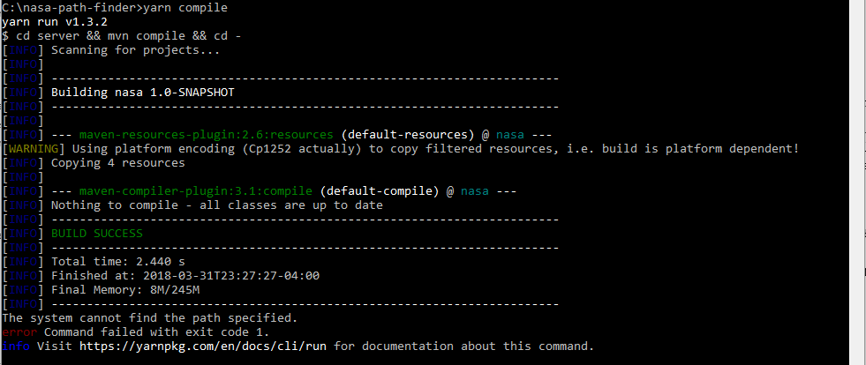

# Frequently Asked Questions

## What do I do if my package does not have a JSON file or NPM?

### Create a Package – package.json

If your package doesn’t have a package.json file, you can create one by doing the following after you’ve forked the git repo and cloned it onto your system.

1. In your command prompt cd into the directory you want to add the json file.

cd < directory path >

2. Type in the command to start the utility that walks you through creating the json file.

npm init

3. Hit enter to use the default package name, which is the directory name, or give it a new name if you’re so inclined.

4. Hit enter to keep the 1.0.0 version or type in number to change it.

5. Hit enter to leave the description blank or type one in to add it.

6. Type in the entry point for the package, typically index.js, if your package has one already you can once again just hit enter. (If your package doesn’t have one you might have to create one, this is the part I’m still unsure of as I’ve tried using a file that the package uses but that doesn’t seem to work.)

7. Test command: If your package has a test file, you can enter the name here, otherwise hit enter.

8. Git repository: Enter it here, otherwise hit enter.

9. Keywords: Type some in, or hit enter to continue.

10. Author: Name, if you want, email in angle brackets, website in parentheses if you have one.

Example: Your Name <you@email.com> (http://your.website.com)

11. Accept default license or type in your information.

12. Type yes to confirm your information was entered correctly.

13. To check that the package was created type dir to show the contents of the current directory, it should include package.json. Or you can just navigate to the folder and look inside it to see that you have one.

dir

14. Push your update to your github fork.

git add .

git commit –m “added package.json”

git push

Screenshot in hello-world directory and keeping the defaults:

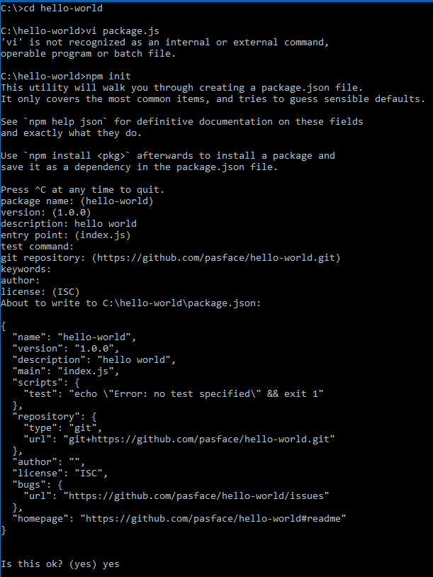

### Install NPM Package

To add the package to the application you need to install it into the modules for it.

1. To install the package you need to cd into your application directory and type in npm install. This will add the package specified to the dependencies list in the application package.json and install the package into the node_modules folder of our application.

cd ../nasa-path-finder

npm install <name of package>

NOTE: 1 If the package you’re installing is one available through NPM, just use the name of the package and voila.

2 If the package you’re trying to install is a GitHub repository, you will need to type in the Git location in the name of package section, but be aware that it can be a pain to deal with if the package isn’t formatted correctly, so do this at your own risk..

# Appendix A: Glossary

DOUG – Dynamic Onboard Ubiquitous Graphics

EVA – Extra-Vehicular Activity

GPU – Graphics Processing Unit (Graphics Card)

ISS – International Space Station

SSD – Solid State Drive

SRS – Software Requirements Specification